Master Weaver: Marie Begaye
The Bunkhouse provides an unusual opportunity to purchase some of the most beautiful traditional ancient rugs! Upon request, you can look at some of the rugs that are for sale and/or you can also commission her to make a rug, but she needs at least 6 months lead time. The months between October and March are the best for her to work on rugs. Contact Marie at this number: 435-459-0787
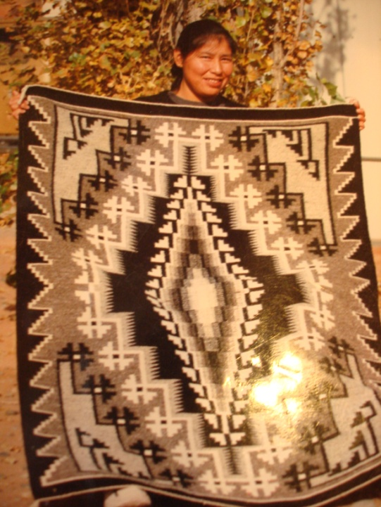
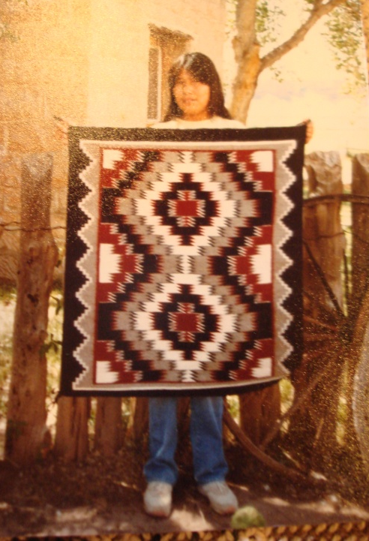
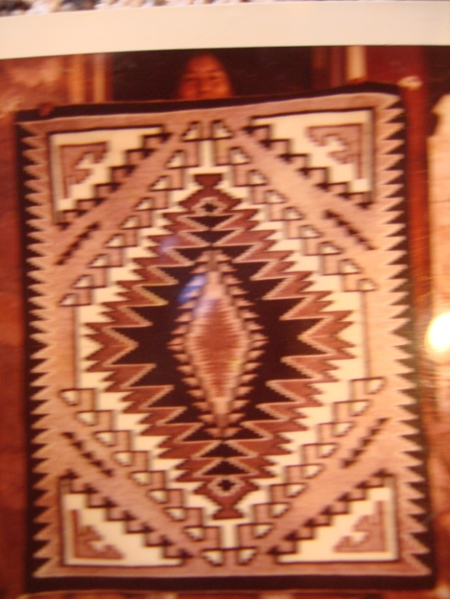
Marie has been weaving for 35 years. She has been taught by her mother ancient designs like Two Grey Hill, Storm Pattern, or Eye Dazzler. All of her rugs are carefully handmade. Her skill and talent is unsurpassed by any other weaver.
